MOBILE STORE

GROUP 10 Project



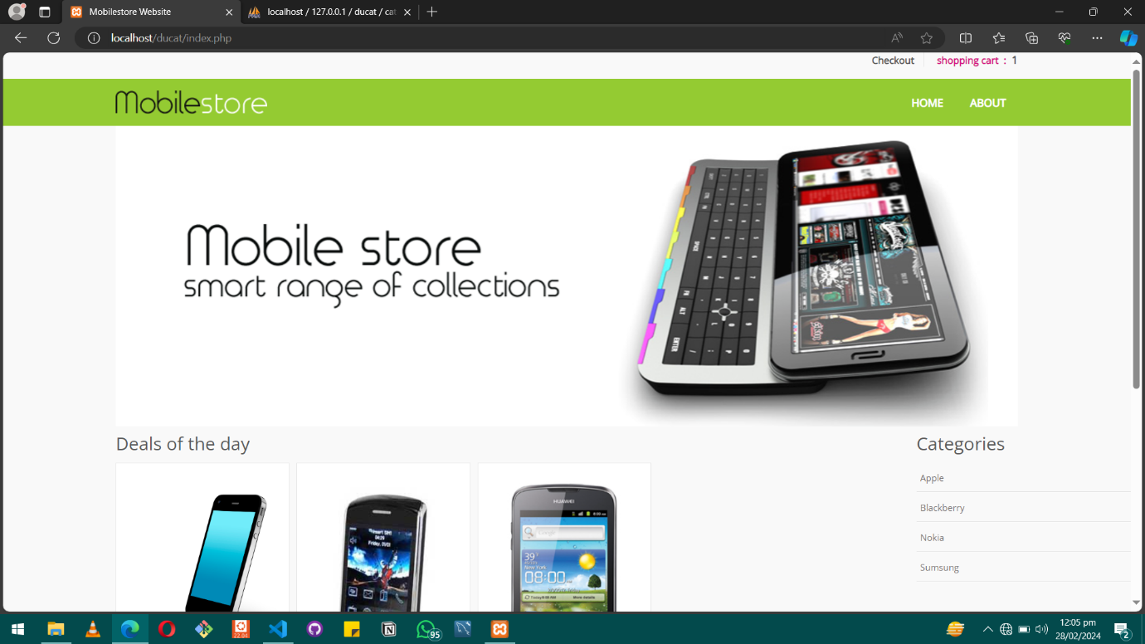

1. **Introduction:**

**.** Overview of the software project.

**.** Software Purpose and goals.

1. **Getting Started:**

**.** Initial steps Instructions for users to start using our software.

1. **User Guide:**

**.** Categories

**.** Product details:

**.** Viewing product descriptions, images, and prices.

**.** Adding products to the shopping cart

**.** Cart and Checkout:

**.** Managing the shopping cart (adding, removing items).

**.** Proceeding to checkout.

1. **Conclusion:**

**. Conclution notes**

1. Overview of the software:

The Mobile Store Software provides a comprehensive solution aimed at streamlining the sale of mobile devices through a user-friendly web application platform. Serving as a digital marketplace, users can effortlessly browse Mobile Categories by Brand, add items to their Cart, adjust quantities, and conveniently manage a diverse range of mobile products from their laptop or desktop.

1. Purpose and goals of the software:

With a focus on enhancing User Experience, the software aims to prioritize providing a visually appealing and intuitive interface. By simplifying the browsing and purchasing process, customers can easily navigate through mobile categories, access detailed product information, and make well-informed buying decisions.

1. Initial steps Instructions for users to start using our software:

Installation of XAMPP:

* Download and install XAMPP from the official website according to your operating system.

- Ensure that both Apache and MySQL services are started from the XAMPP Control Panel post-installation.

*- Setting Up MySQL Database:

- Launch MySQL Workbench and connect to the MySQL server running on localhost (port 3306).

- Create a new schema (database) for the Mobile Store Software by right-clicking on "Schemas" and selecting "Create Schema...".

- Enter a name for the schema (e.g., "ducat") and click "Apply" to create the new database.

- Execute the provided SQL script or run SQL queries to create the necessary tables and schema for the software within the newly created database.

*. Extract the files and copy them to the appropriate directory within the XAMPP installation directory (typically "htdocs").

- Ensure that the file structure is maintained correctly.

Configuration File Setup:

- Locate the configuration file (e.g., "DBController.php") within the software files.

- Open the configuration file in a text editor and update the database connection settings (hostname, username, password, database name) to match your MySQL configuration.

- Save the changes to the configuration file.

Accessing the Software:

- Open a web browser and navigate to http://localhost/ducat/index.php.

- If configured correctly, you should see the homepage of the Mobile Store Software.

- Users can now view mobile products, add items to their Cart, and proceed with the checkout process.

1. **User Guide:**

1. Categories (Mobile Brands):

- Go to the "Categories" section of the Mobile Store Shop Software.

- Explore the available mobile brands, including "Apple," "Samsung," "Blackberry," etc.

- Select a brand to see the list of mobile products associated with that brand.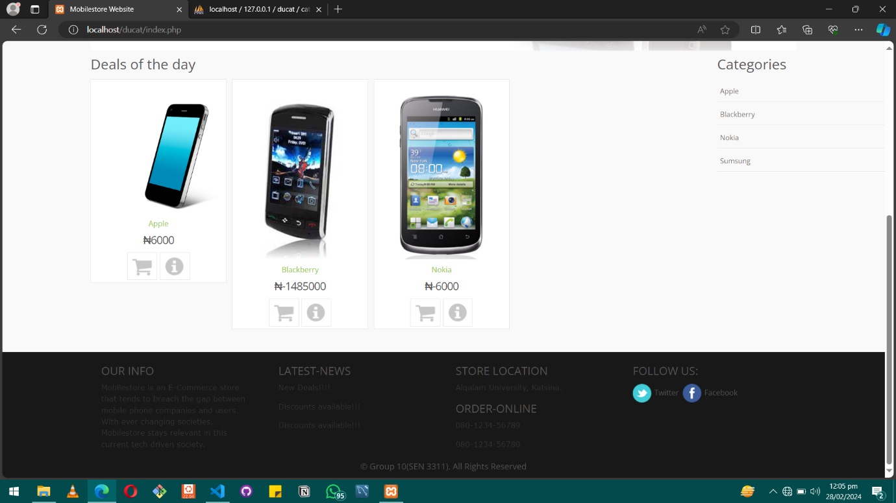

2. Product Detailss

- Choose a mobile product from the list presented within a specific brand category.

- Explore comprehensive details about the product, including its description, images, specifications, and pricing.

- Navigate through the product images to examine the device more closely.

3. Adding Products to the Shopping Cart:

. Once you've found a mobile device you'd like to purchase, locate the "Add to Cart" button below the product details.

. Click on the "Add to Cart" button to add the mobile device to your shopping cart.

4. Cart and Checkout:

- Access your shopping cart by clicking on the shopping cart icon or navigating to the "Cart" section within the software.

- Within the shopping cart, you can review the mobile devices you've added, along with their quantities and prices.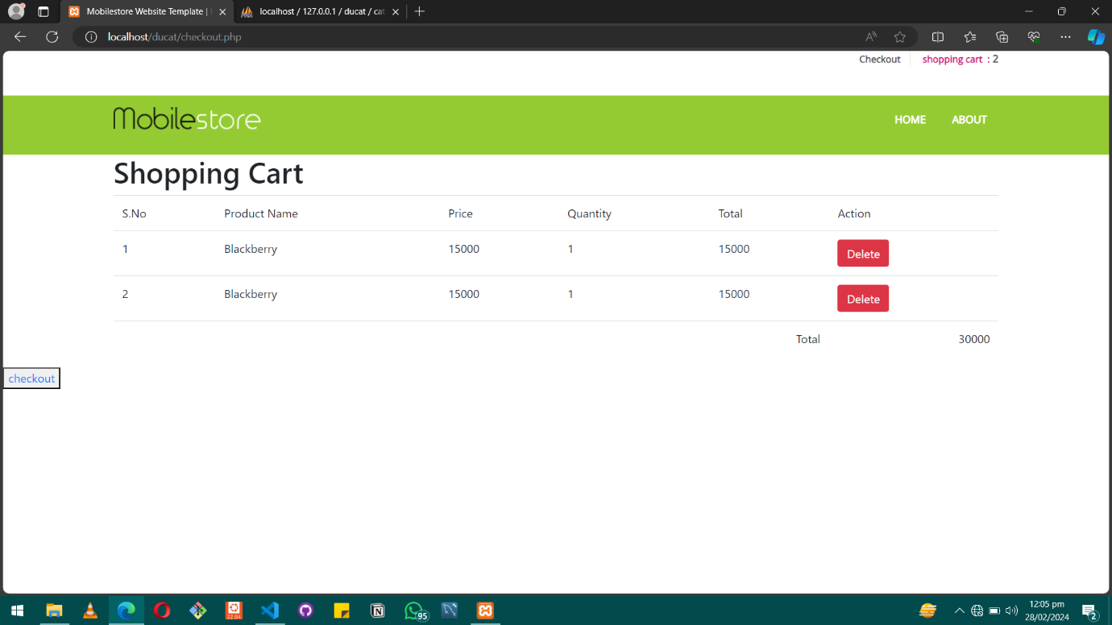

To handle the shopping cart:

i. Modify the quantity of a mobile device by utilizing the quantity field and updating it accordingly.

ii. Remove a mobile device from the cart by clicking on the "Delete" button adjacent to the product.

1. **. Conclusion:**

The Mobile Store Software transforms the mobile shopping experience by offering a seamless and intuitive web application accessible from laptops and desktops. Emphasizing user-friendliness and convenience, it enables customers to effortlessly browse through an extensive collection of mobile brands, access detailed product descriptions, images, and prices, and easily add desired items to their shopping carts.

With its streamlined checkout process, users can efficiently manage their shopping carts, make adjustments to quantities, and securely proceed with transactions, ensuring a hassle-free purchasing journey. Featuring a diverse selection of mobile brands including Apple, Samsung, and Blackberry, the software caters to the diverse preferences of users, providing a comprehensive solution for their mobile device requirements.